From model

peopleThank.js

const PeopleThankSchema = new Schema({

module.exports = mongoose.model("peoplethank",PeopleThankSchema);

From the seeder.js

const PeopleThank = require('../models/peoplethank');

const seedDB = async () => {

    await PeopleThank.deleteMany({});

    const res = await PeopleThank.insertMany(sampleData)

        .then((data) => console.log('Data inserted'))

        .catch((e) => console.log(e));

In mongo

When we put in the command db.peoplethanks.find() we see all of the keys and values uploaded by the seeder.js file

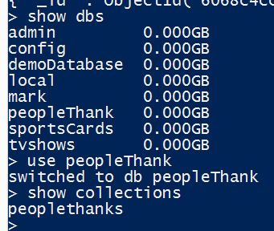

Note, because I uploaded the seeder file with different module.exports = mongoose.model(“right here”

When I change it from peoplethank to fkjsdkj to markSam , this changed what the index displayed and what I could work with when the app.js was running

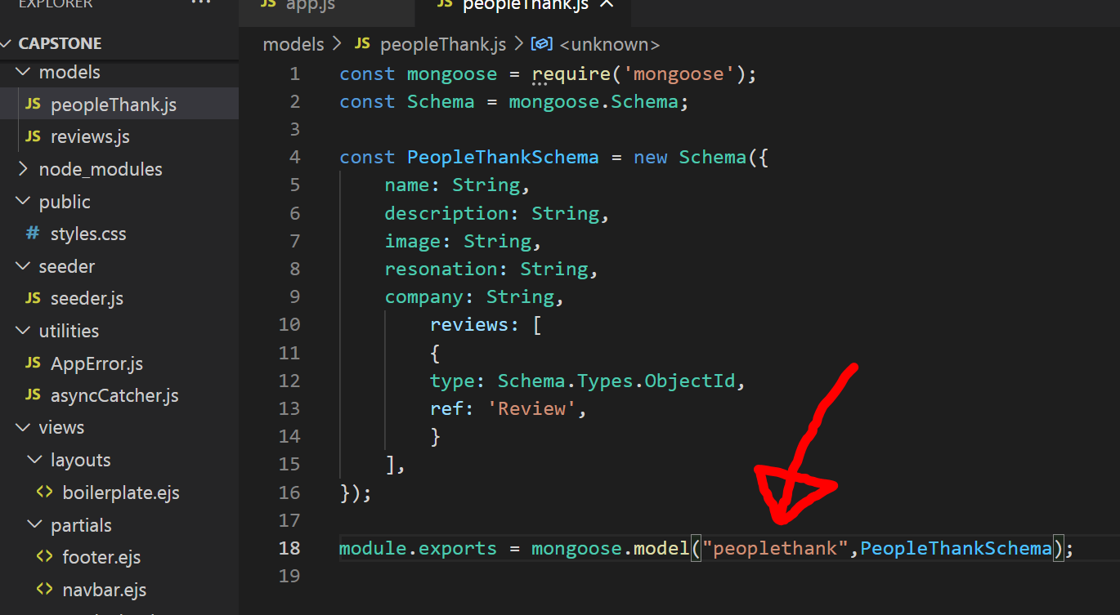

On app.js the data on the server is made available to app.js by

const PeopleThank = require('./models/peoplethank');

and can be used within the app.js by the const variable PeopleThank

**app.js- index**

peopleThanks = PeopleThank.find

* Index.ejs > {peopleThanks}

**Index.ejs**

Loop through ( let peopleThank of peopleThanks)

peopleThank.id

**app.js- show**

peopleThank = await PeopleThank.FindById

{peopleThank}

**show.ejs**

peopleThank.name .company .description

~~go to the peopleThank folder / load the value from PeopleThank.find on to const peopleThanks /res.render on to the index.eis via peopleThank/index, {peopleThanks}~~

form index.ejs loop through from peopleThanks and load on to peopleThank , showing id and name

<% for (let peopleThank of peopleThanks) { %>

     <li><a href="peoplethank/<%= peopleThank.id %>"><%= peopleThank.name %>